
SPECIALIST MATHS 3 & 4
TRIAL EXAMINATION 2
SOLUTIONS
2018

Section A – Multiple-choice answers
1. D 6. C 11. C 16. C
2. A 7. E 12. D 17. E
3. E 8. B 13. A 18. B
4. B 9. A 14. C 19. A
5. D 10. E 15. B 20. D

Section A - Multiple-choice solutions

Question 1

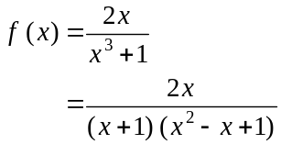
Since 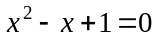 has no real solutions, the only vertical asymptote is .
The horizontal asymptote is 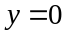
The answer is D.

Question 2

For 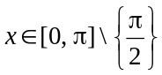,
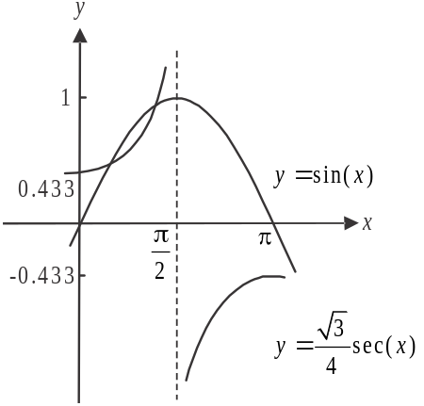
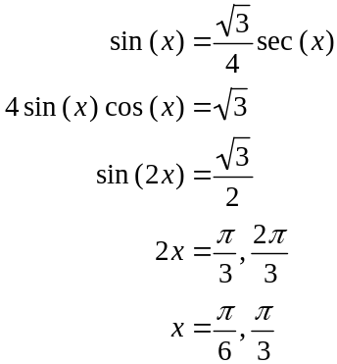


So, from the graph, 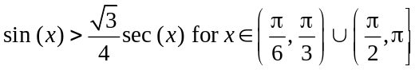.
The answer is A.
Question 3

We require that
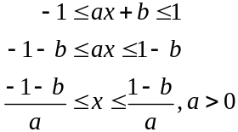
The implied domain is 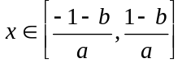.
The answer is E.

Question 4

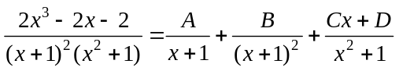
The answer is B.

Question 5
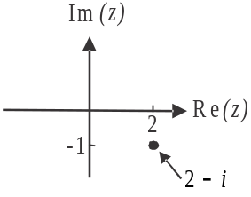
Using the graph, options A, B and C can be ruled out.

Alternatively, for option A, when 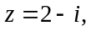
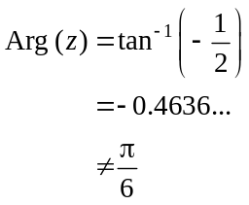
so reject option A.
For option B,
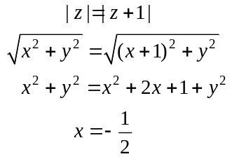
When 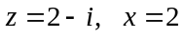 so reject option B.
For option C, 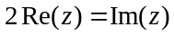
When 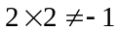
So reject option C.
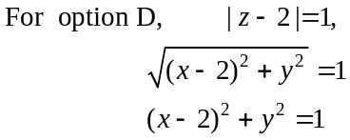
When 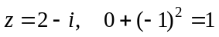 so option D is correct.
Out of interest, for option E, 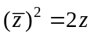
When 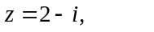 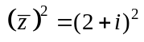
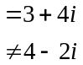
The answer is D.
Question 6

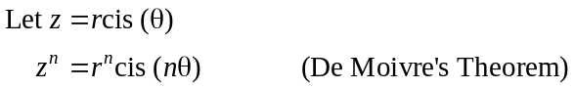
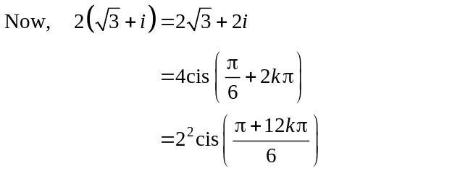
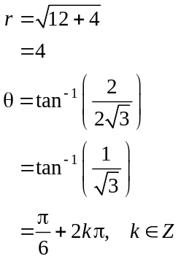

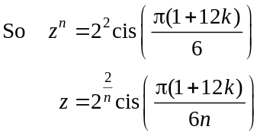
The answer is C.

Question 7
For the equation 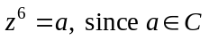, then the 6 solutions to this equation lie on a circle with its centre at the origin.
Since one of the solutions is 2, the radius of this circle is 2.
Also, the solutions are equally spaced around the circle at intervals
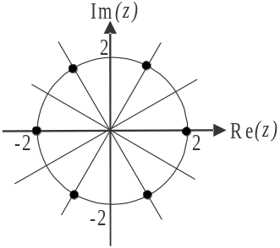
of 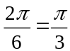.
The solutions are
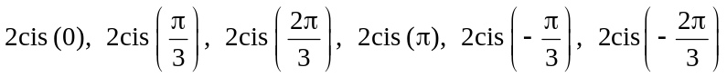
Note that 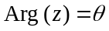 i.e. we want the principal valued argument
and 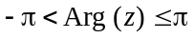 (formula sheet) so the value of
could be .
The answer is E.

Question 8

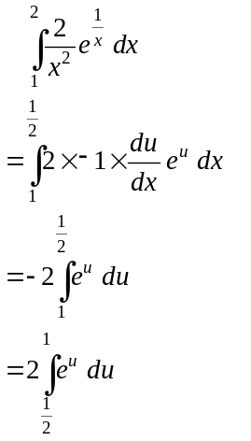
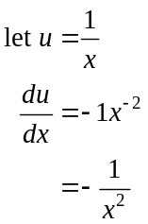
Also, if 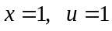
and if 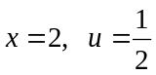
The answer is B.
Question 9

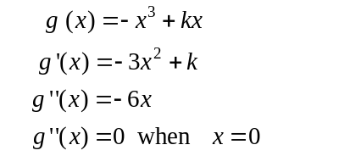
So the stationary point of the gradient graph 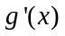, occurs at .
The gradient graph of g is a concave downward parabola with turning point at 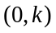 so the gradient of g will always be strictly decreasing for .
The answer is A.

Question 10

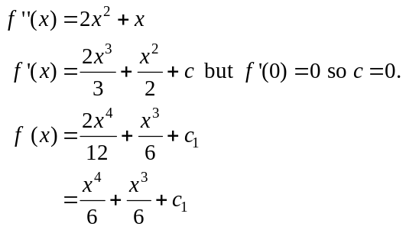
A possible graph of f (when 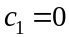) is

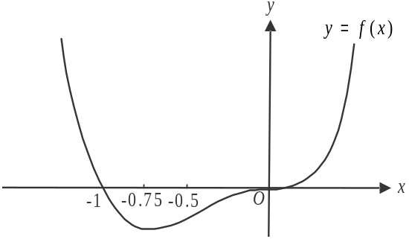

Stationary points occur when 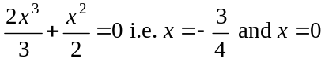.
Points of inflection occur when 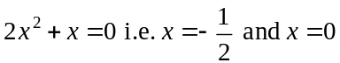.
So a stationary point of inflection occurs at .
Only option E describes the graph.
The answer is E.

Question 11
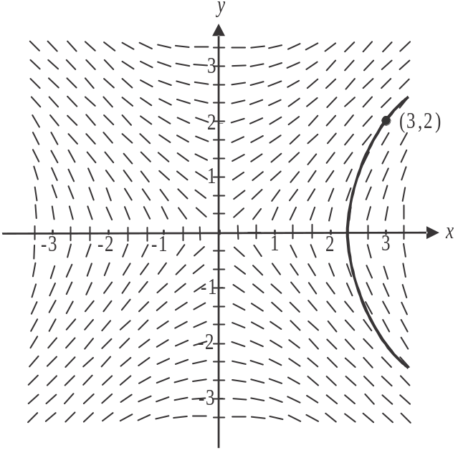

The approximate solution curve corresponding to the condition 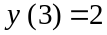 is drawn above.
The value of x when for this solution curve could be 2.2.
The answer is C.

Question 12

The area above the t-axis is given by .
So the body travels a total of 7 units in one direction.

The area below the t-axis is given by .
When the area below the t-axis is 7, the body has returned to its initial position.

Between ,
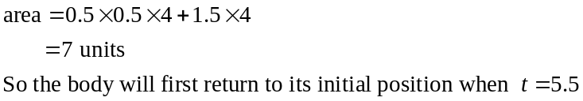

The answer is D.
Question 13
Let O be the origin.
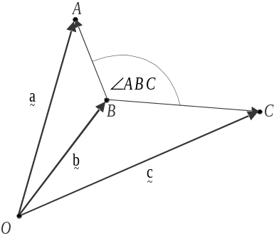
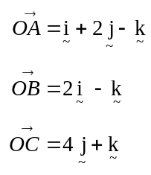
From the diagram, is the angle between 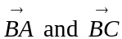.
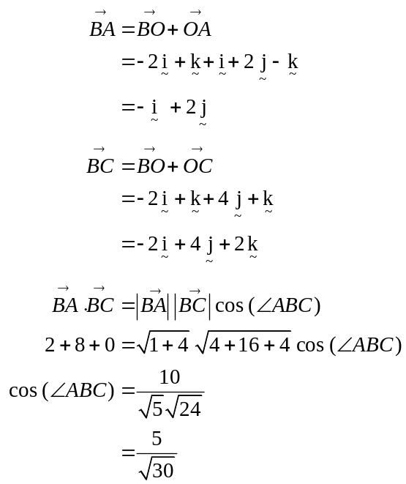
The answer is A.

Question 14
Option B is true since 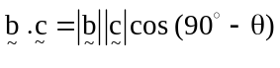
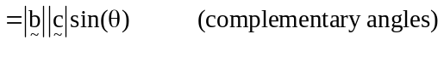
Option C is not true since 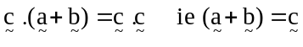
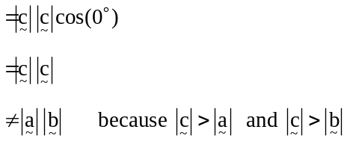
Option D is true because it is a classic example of a scalar product of two vectors.
Option E is true since 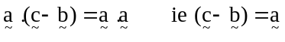
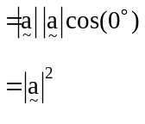
The answer is C.
Question 15
Method 1
Consider the force vectors head to tail.
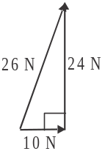
We see that the resultant force has
magnitude of 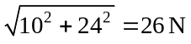.

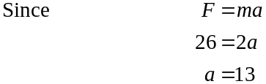
The answer is B.

Method 2
resultant force 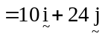
so 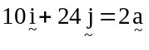
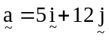
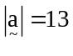
The answer is B.

Question 16
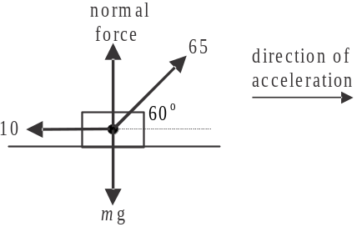

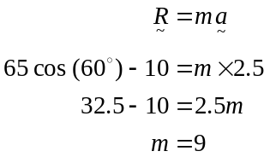
The answer is C.

Question 17
Note that , so the m kg particle will accelerate downwards and the n kg particle will accelerate upwards.

For the m kg particle:

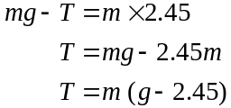
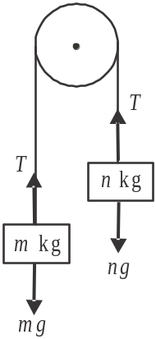

For the n kg particle:

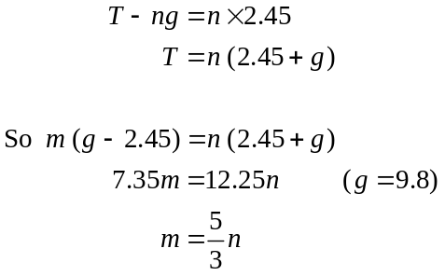
The answer is E.
Question 18

A Type I error occurs when 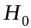 is rejected but it is true.
Only option B gives these two options.
The answer is B.

Question 19
An approximate confidence interval for is given by 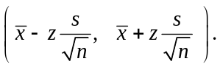
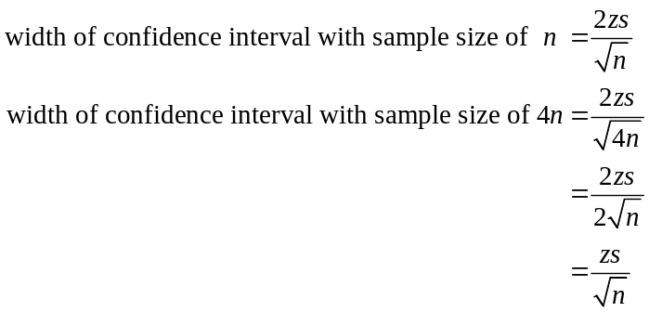
The width of the confidence interval has been halved, i.e. it has been decreased by a factor of 2.
The answer is A.

Question 20

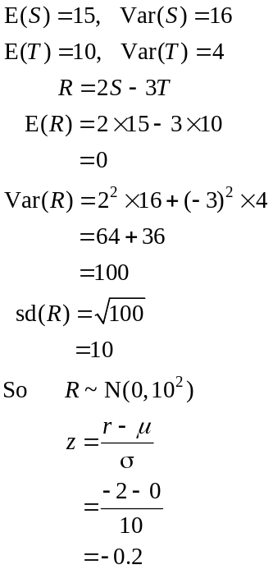
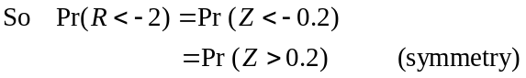
The answer is D.
SECTION B

Question 1 (10 marks)

- 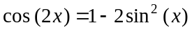
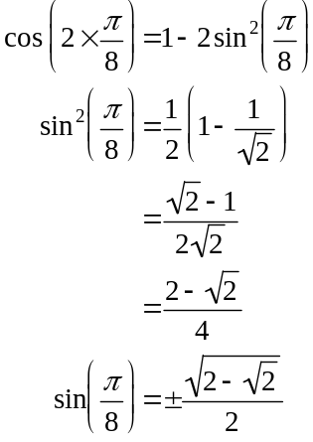
(1 mark)
Since 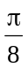 is a first quadrant angle, 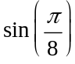 is positive.
So 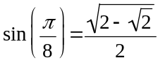 as required. (1 mark)

- 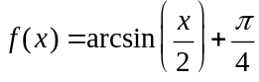
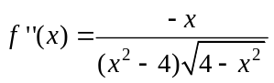 (1 mark)
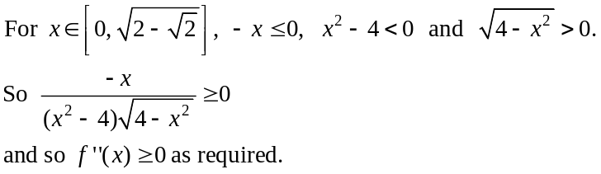
(1 mark)

- From part b., since 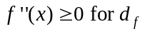, the graph of f is concave up (and includes a point of inflection at the left endpoint).
Endpoints:
When 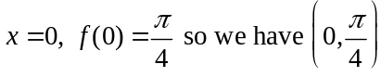 as our left endpoint.
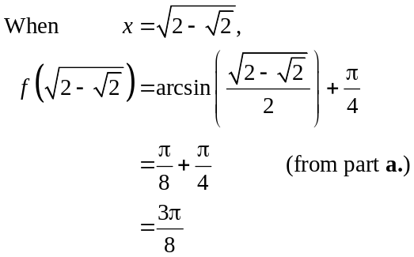
So we have 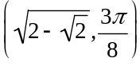 as our right endpoint.
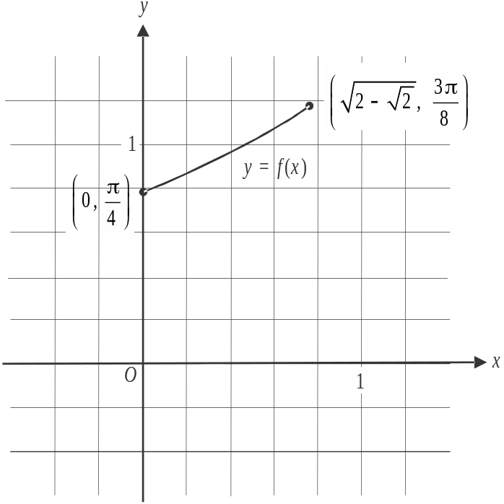

(1 mark) – correct left endpoint
(1 mark) – correct right endpoint
(1 mark) – correct (very slight) upward concavity
- i. 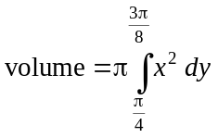 (1 mark)
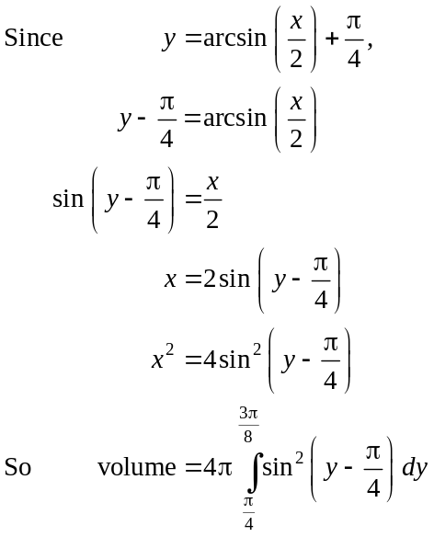
(1 mark)
  - From part i.,
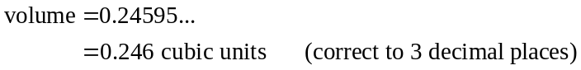
(1 mark)
Question 2 (12 marks)
- 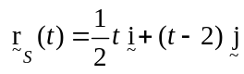
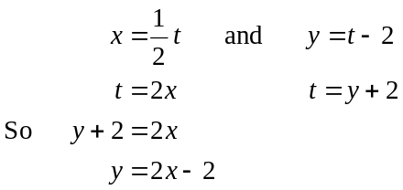
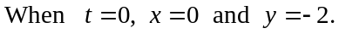
Starting point is 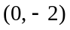.
Since this is an endpoint, the direction in which the ship moves is obvious but just to double-check, when 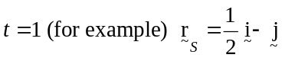, i.e. the ship is at the point 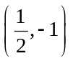.
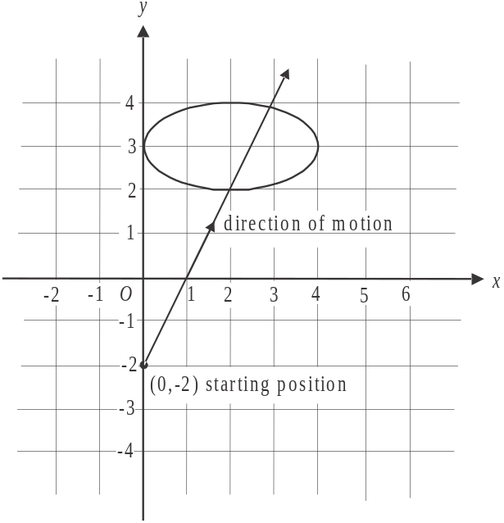

(1 mark) – correct path
(1 mark) – correct starting position
and direction of motion
- 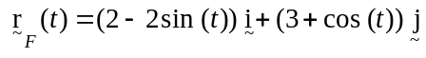
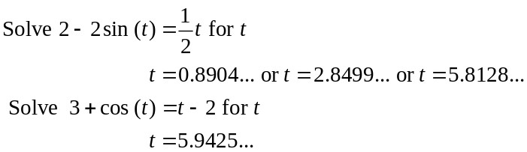
(1 mark)
The times when the components of the position vectors are equal are different to the time when the components of the position vectors are equal. Hence the ship and the ferry don’t collide.
(1 mark)
- 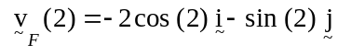
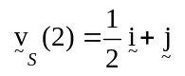 (1 mark)
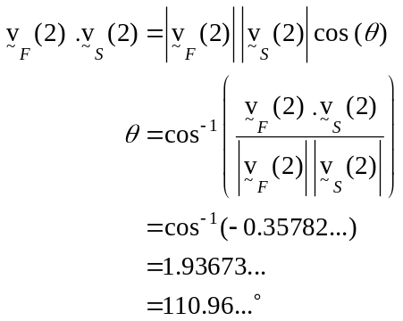
(where is the angle between the two vectors)
The angle between the path of the ferry and the ship is 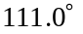 (to one decimal place).
(1 mark)

- 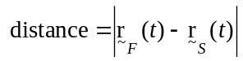
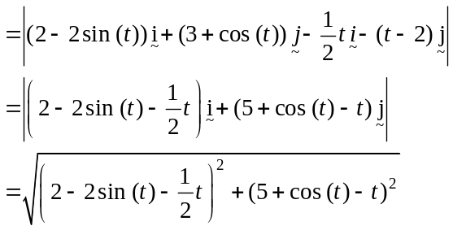
(1 mark)

- Graph the function found in part d. The minimum value occurs at 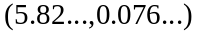.
The minimum distance between the ferry and the ship is 0.1 km (correct to one decimal place). (1 mark)
This occurs when (correct to one decimal place). (1 mark)
(Note that this answer seems feasible according to our answer to part b. where it was shown that whilst the vessels didn’t collide they came awfully close at around
to !)

- Using the graph, the paths first cross at the point 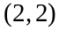.
The Cartesian equation of the ship is 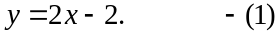.
The Cartesian equation of the ferry is found by equating
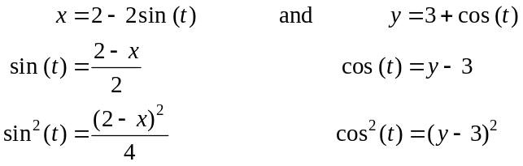
(1 mark)

Solve (1) and (2) simultaneously using CAS.
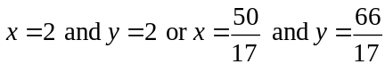
The paths cross at 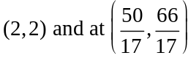.
(1 mark)
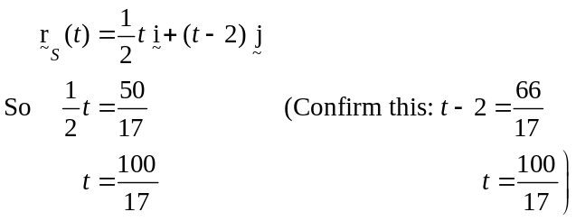
The ship is next at the point where the paths cross when 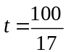.
So 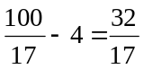.
So 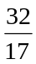 hours later the ship next crosses the path of the ferry.
(1 mark)
Question 3 (10 marks)

- 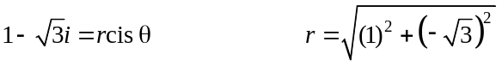
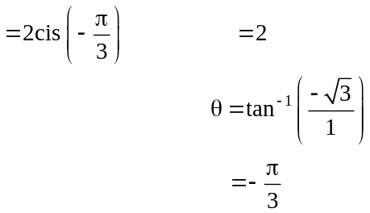
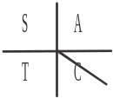
base angle is 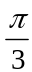
(1 mark)

- The perpendicular bisector is given by
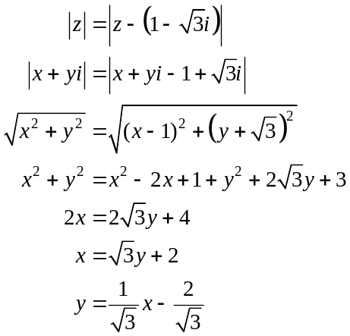
(1 mark)
(1 mark)

- Method 1 – using the complex equation
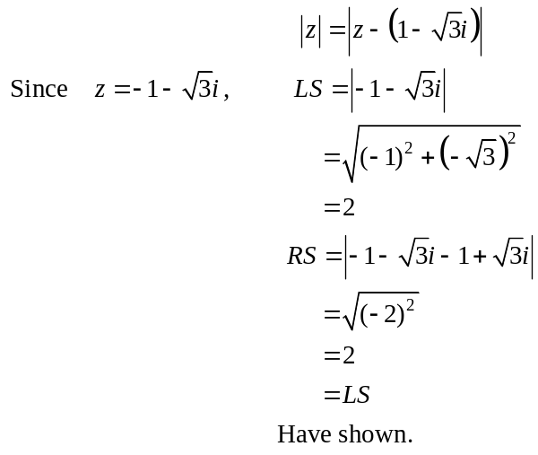
(1 mark)
c. (cont’d)
Method 2 – using the Cartesian equation.
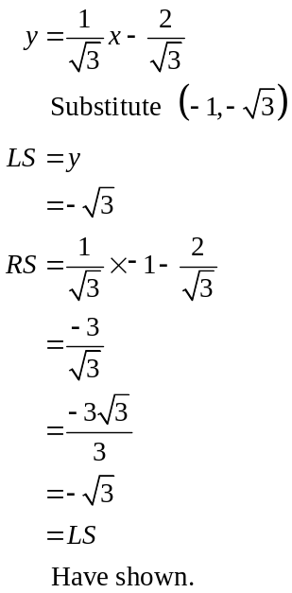
(1 mark)

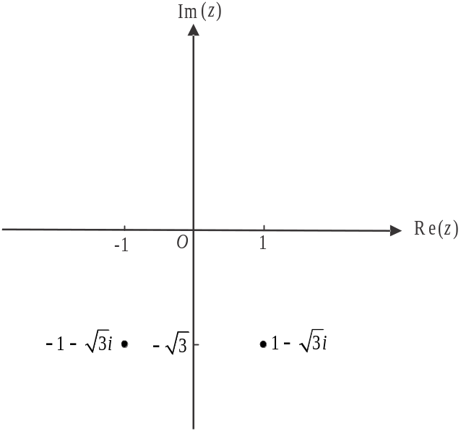

(1 mark)

e. Method 1
The equation of the circle is 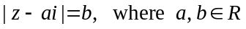 and so the centre of the circle lies on the y-axis. (1 mark)
The centre is equidistant from O and 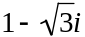 so it must be on the perpendicular bisector. The y-intercept of the perpendicular bisector is 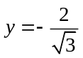 using our result from part b. (i.e. the equation of the perpendicular bisector is 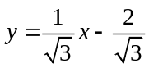), so therefore 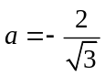. (1 mark)
The radius of the circle is the distance from 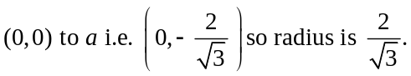
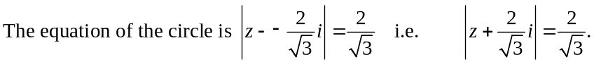 (1 mark)
Method 2
The three complex numbers 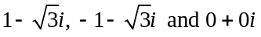 satisfy the equation .
Substituting , gives
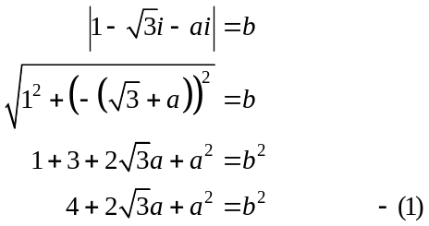
(1 mark)
Substituting 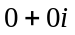 gives
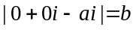
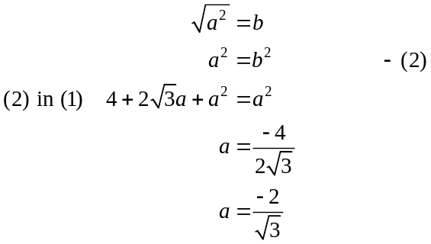
(1 mark)
Note that (2) gave us 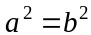, but we obtained this by squaring both sides of the equation 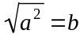. In doing so, we introduced an extra solution. (i.e. )
Note that tells us that b can only be positive.
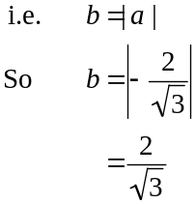
(1 mark)

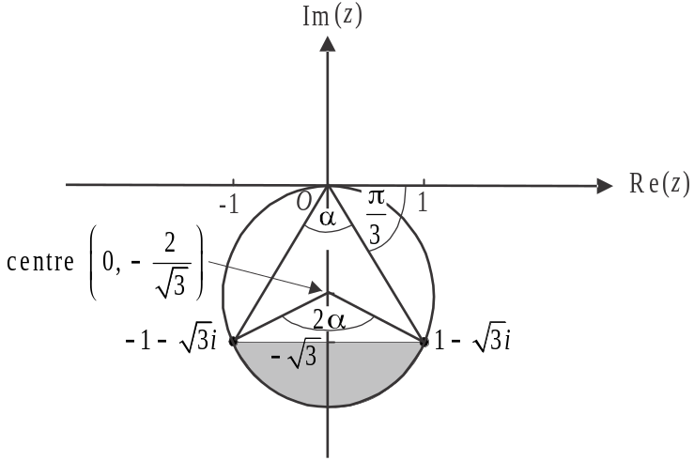

The area required is shaded in the diagram above.
In the circle found in part e., the angle at the centre, subtended by the chord passing through 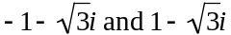 (ie 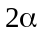), is twice the angle at the circumference subtended by the same chord (ie ). (Specialist Maths Units 1 & 2)
Now from part a. we saw that 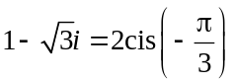.
Using symmetry, 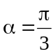.
So the angle at the centre is 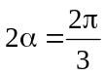 (1 mark)
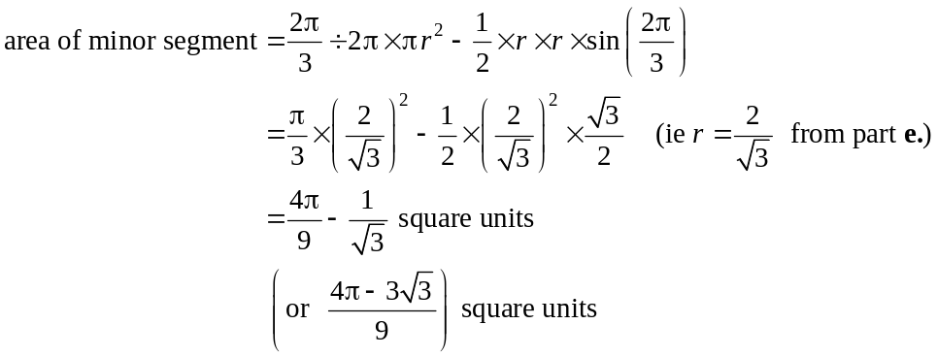
(1 mark)
Question 4 (10 marks)

- Draw in the forces.
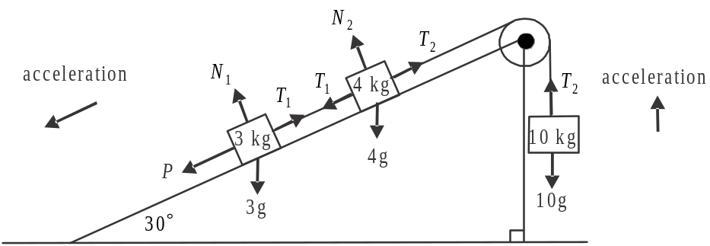

- Around the 10 kg mass, 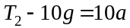. (1 mark)
- Around the 4 kg mass,
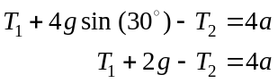
(1 mark)
- Around the 3 kg mass,
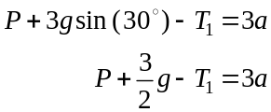
(1 mark)
- From part a. i., 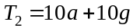.
So using part a. ii., we have
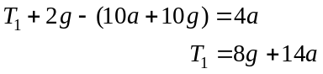
Finally using part a. iii.,
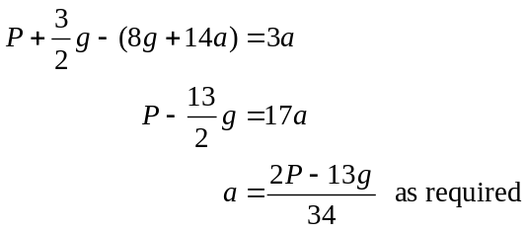
(1 mark)
- Acceleration is constant, and we have,
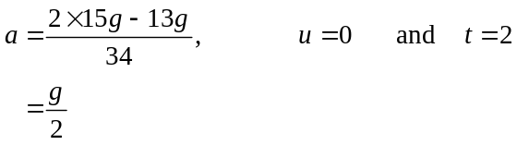

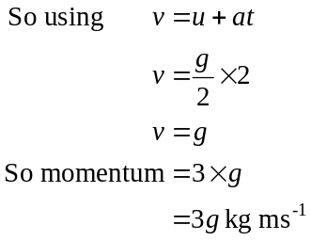
(1 mark)
(1 mark)
d. 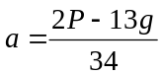 (from part b.)
The system is in equilibrium when .
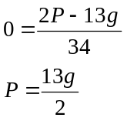
(1 mark)
e. The pulling force P is removed and the direction of the acceleration for each of the masses is reversed as shown below.

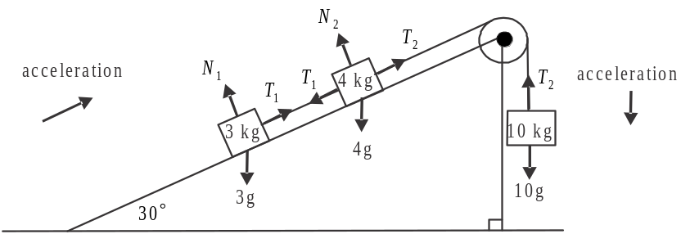

Around the 10 kg mass, and taking positive acceleration as downward,
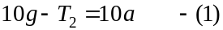 (1 mark)
Around the 4 kg mass and taking positive acceleration as up the plane,
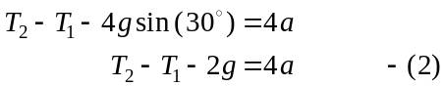
Around the 3 kg mass and taking positive acceleration as up the plane,
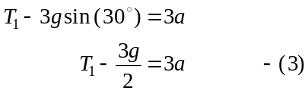
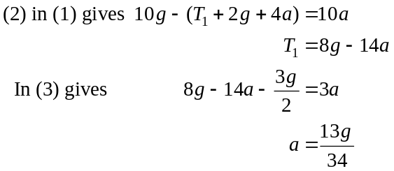
(1 mark)
When the system was in equilibrium,
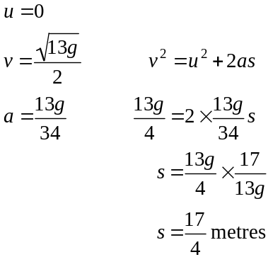
The 10 kg mass was 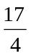metres above the ground. (1 mark)
Question 5 (9 marks)

- 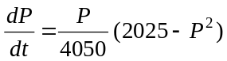
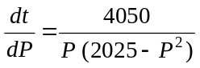

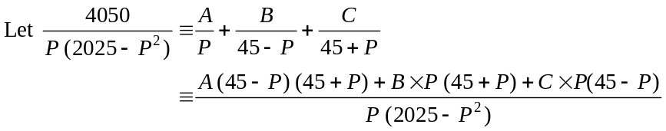

True iff

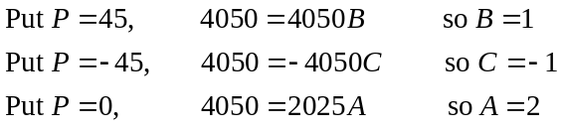

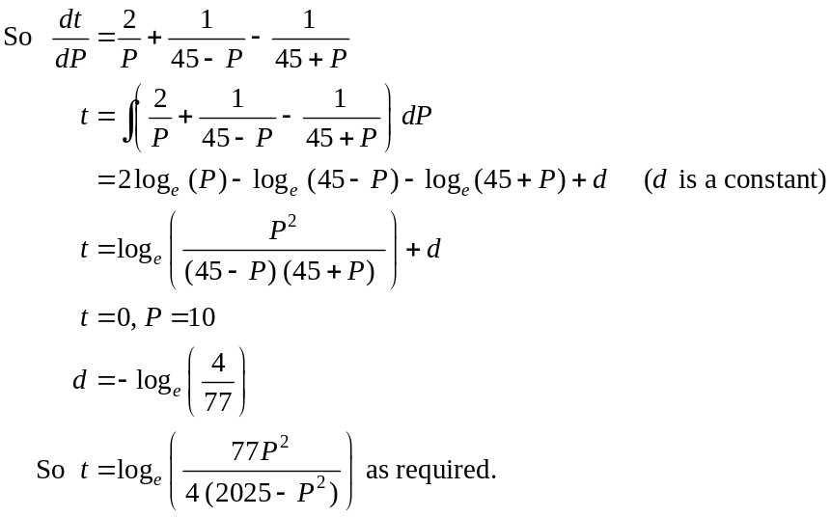
(1 mark)
(1 mark)
(1 mark)

- Solve 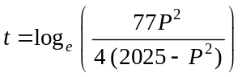 for P using CAS.
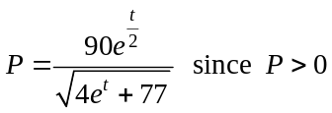 (1 mark)

Method 1 – using algebra
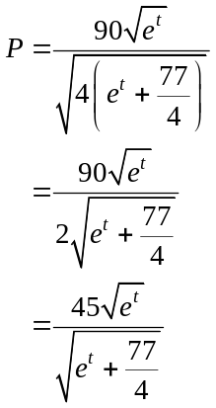
As 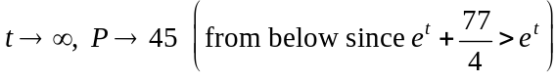.
The limiting value of P is 45.
(1 mark)

Method 2 using a graph

Using your CAS, sketch the graph of 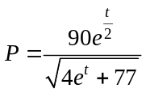.
As 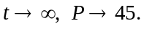
The limiting value of P is 45.
(1 mark)

- 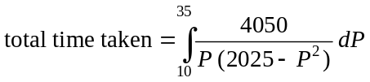
(1 mark) – correct integrand
(1 mark) – correct terminals

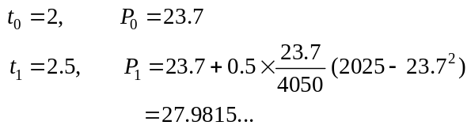
(1 mark)
The estimated value of P when is 27.98 (correct to two decimal places).
(1 mark)

Question 6 (9 marks)

- 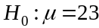
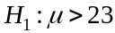
(1 mark)

- Let 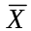 represent the distribution of the sample mean.
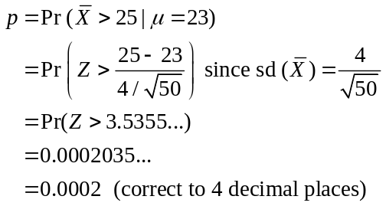
(1 mark)
(1 mark)

- Since 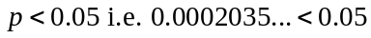, the sample supports the view that the waiting times are greater than those published.
(1 mark)

- Solve 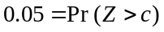 for c. (1 mark)
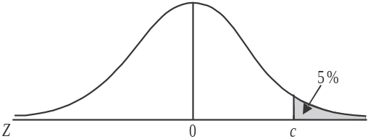
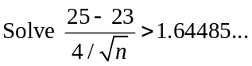 (1 mark)
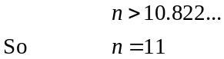
(1 mark)

- Let W be the random variable representing the waiting time for a client. 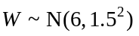.
Let G be the random variable representing the waiting time of a group i.e.
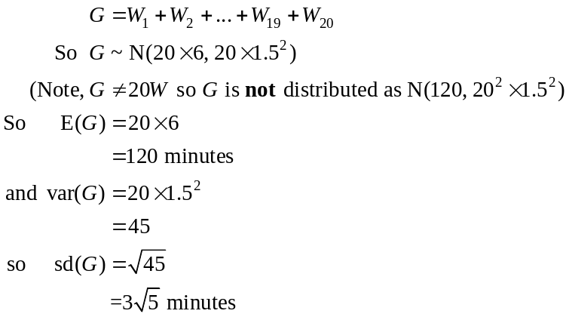
(1 mark)
(1 mark)

